Development of control strategies for seismic reproduction on LNEC’s uniaxial seismic platform

Desenvolvimento de estratégias de controlo para reprodução de sismos em mesa sísmica uniaxial do LNEC

Afonso Costa Henrique^{1,2} | Miguel Ayala Botto² | Fernando Pires de Oliveira¹
¹LNEC – Laboratório Nacional de Engenharia Civil, Portugal ²IST – Instituto Superior Técnico, Portugal

Abstract
In the scientific area of seismic engineering, while computational simulations have become highly sophisticated and efficient, they still face limitations in accurately modelling complex, nonlinear, or poorly understood behaviours. Numerical simulations, even with advanced methods, require experimental benchmarks to ensure accuracy. Machine learning approaches also rely on experimental data for training and updating models. Experimental testing provides critical validation and calibration for these models. In summary, seismic experimental testing remains indispensable for validating models, understanding complex behaviours, and ensuring structural safety. In this paper, a computational model of LNEC’s uniaxial seismic platform is used to compare the performance in terms of response spectra resulting from three distinct control strategies: the currently used method which consists on iterative offline pseudo-adaptive open-loop control with the tests running in closed loop, a tuned PIDF controller, and optimal control. The results indicate that both the tuned PIDF and the optimal controller offer superior performance in terms of response spectra compared to the iterative method, with optimal control providing the best results in every instance. However, the performance of each of the methods depends on identifying the system, and the sensitivity of each method to quality of the identification is still unknown and requires further study.
Keywords: Earthquake Engineering, Control Systems, System Identification, Closed-loop Identification

Resumo
Na área científica da engenharia sísmica, apesar da crescente sofisticação e eficiência das simulações computacionais, ainda se enfrentam limitações na modelação precisa de comportamentos complexos, não lineares ou pouco estudados. As simulações numéricas, mesmo com métodos avançados, requerem referências experimentais para garantir a sua precisão. As abordagens de aprendizagem automática também dependem de dados experimentais para treinar e atualizar modelos. Os testes experimentais fornecem validação e calibração críticas para esses modelos. Em resumo, os testes experimentais sísmicos continuam a ser indispensáveis para validar modelos, compreender comportamentos complexos e garantir a segurança estrutural. Neste artigo, um modelo computacional da plataforma sísmica uniaxial do LNEC é utilizado para comparar o desempenho em termos de espetro de resposta resultante de três estratégias de controlo distintas: o método iterativo atualmente utilizado, que consiste num controlo pseudo-adaptativo offline em anel aberto e com o ensaio a decorrer em anel fechado, um controlador PIDF sintonizado, e o controlo ótimo. Os resultados indicam que ambos os controladores oferecem desempenho superior em termos de espectros de resposta em comparação com o método iterativo, sendo o controlo ótimo o método com o melhor desempenho em todas as simulações. No entanto, o desempenho de cada um dos métodos depende da identificação do sistema, e a sensibilidade de cada método à qualidade da identificação ainda é desconhecida e requer mais estudos.
Palavras-chave: Engenharia Sísmica, Controlo de Sistemas, Identificação de Sistemas, Identificação em Anel Fechado

1- Introduction
The current seismic platform testing process at LNEC consists on iteratively synthesizing a drive signal, distinct from the reference signal, such that the seismic platform replicates the response spectra of the reference signal, i.e. the earthquake. At the end of each test, the system's performance is evaluated by comparing the response spectrum of the reference signal with that of the signal measured on the platform. However, it is not always possible to achieve satisfactory performance with the command signal synthesized initially, and it may be necessary to generate more than one command signal and carry out additional tests at the same amplitude. This procedure, although necessary in some situations, should be avoided as it induces additional damage to the structure.

2- Objectives
The objective of this work is to implement a controller, or strategy, to ensure that the seismic platform reproduces the test seismic signal (reference/earthquake) as accurately as possible.

3- Control Strategies: Performance in simulation environment
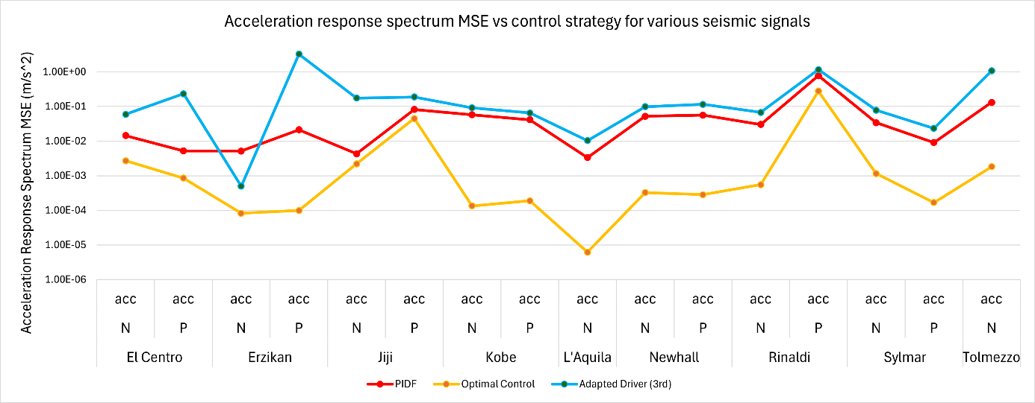
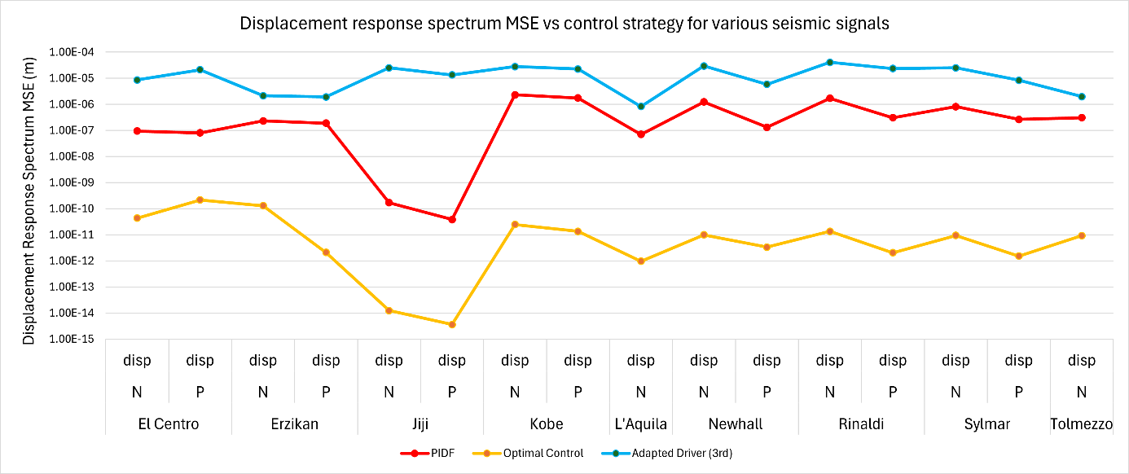

4- Conclusions
The results indicate that the controllers previously studied offer superior performance in terms of response spectra compared to the adapted drivers, while also requiring less user intervention doing so, with optimal control providing the best results in every instance. However, both the performance of the controllers and the adapted drivers depends on identifying the system, and the sensitivity of each method to quality of the identification is still unknown.

